EMPLOYEE PAYROLL AND BONUS SYSTEM
[Company name] | [Company address]
GAUTENG CITY COLLEGE
Bongiwe Masuku
2026

INTRODUCTION:
This project is a C++ console-based Employee Payroll and Bonus System designed to calculate employees' total pay. Each employee has a basic salary and may receive additional bonuses based on performance ratings and years of service. The program highlights the implementation of fundamental programming concepts, including conditional statements, loops, variables, data types, calculations, and input validation.

BONUS RULES:
The bonus rules are structured based on employees' Performance ratings. Those receiving a rating of 5 obtain a 20% bonus, while a rating of 4 earns a 15% bonus. Rating 3 results in a 10% bonus, a rating 2 gives a 5% bonus, and a rating 1 receives no performance bonus at all. Additionally, employees with 5 or more years of service are eligible for an extra 5% service bonus. These guidelines aim to incentivize exceptional performance and acknowledge long-term service.

CONDITIONAL STATEMENTS:
The program employs if and else if statements to calculate performance bonuses based on ratings. For a performance rating of 5, an employee earns a 20% bonus, while a rating of 4 results in a 15% bonus. Additionally, an if statement checks if an employee has completed 5 years of service or more.

FOR LOOP:
A for loop is utilized to manage the processing of multiple employees. Initially, the user inputs the total number of employees. The loop iterates, allowing the user to input details and perform payroll calculations for each individual employee. Each for loop is structured with an initial value, a condition to continue iterating, and an update statement to progress through the loop.

VARIABLES AND DATA TYPES:
The program implements different data types for handling employee-related information. Integer variables are utilized for values like employee ID, performance rating, and years of service. Double data types are applied to salary and bonus amounts, accommodating decimal values. A string data type is designated for the employee's name, as names consist of text characters.

INPUT VALIDATION:
The program ensures that the basic salary is non-negative, verifies that the performance rating falls within the range of 1 to 5, and confirms that years of service is also non-negative. In case of any invalid input, the program prompts the user to re-enter the correct value.

TESTING:
TEST 1:
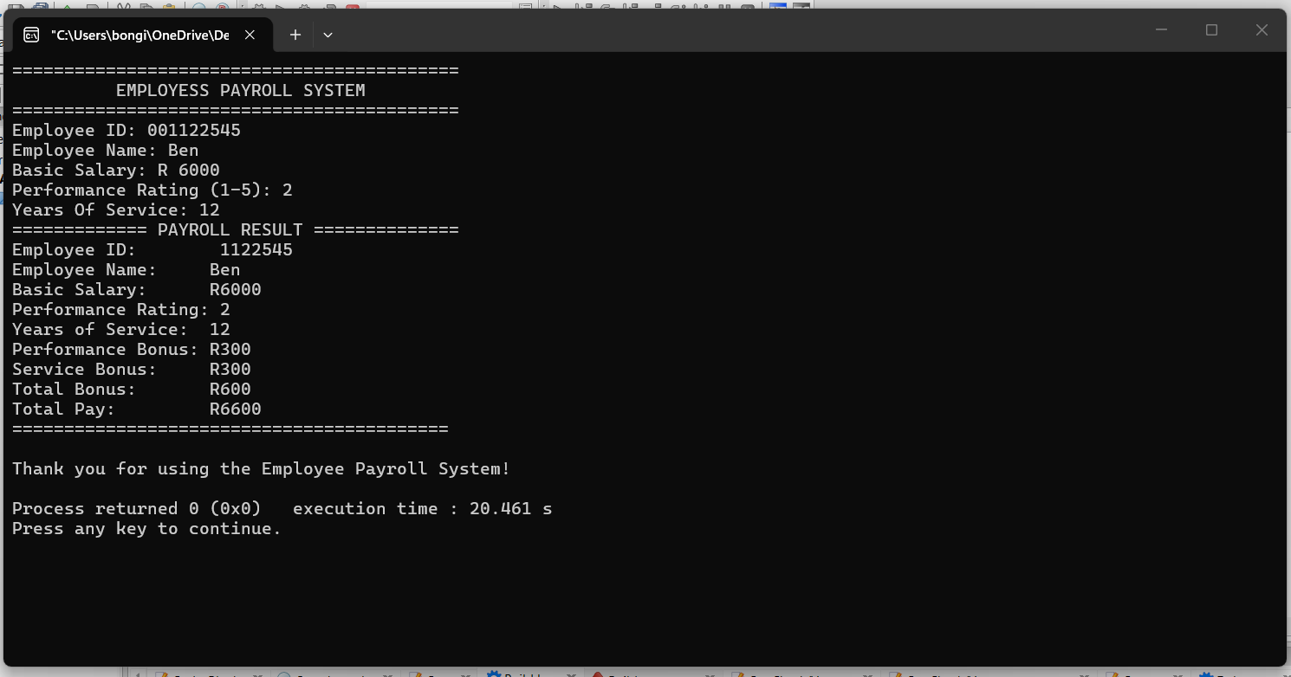
TEST 2:
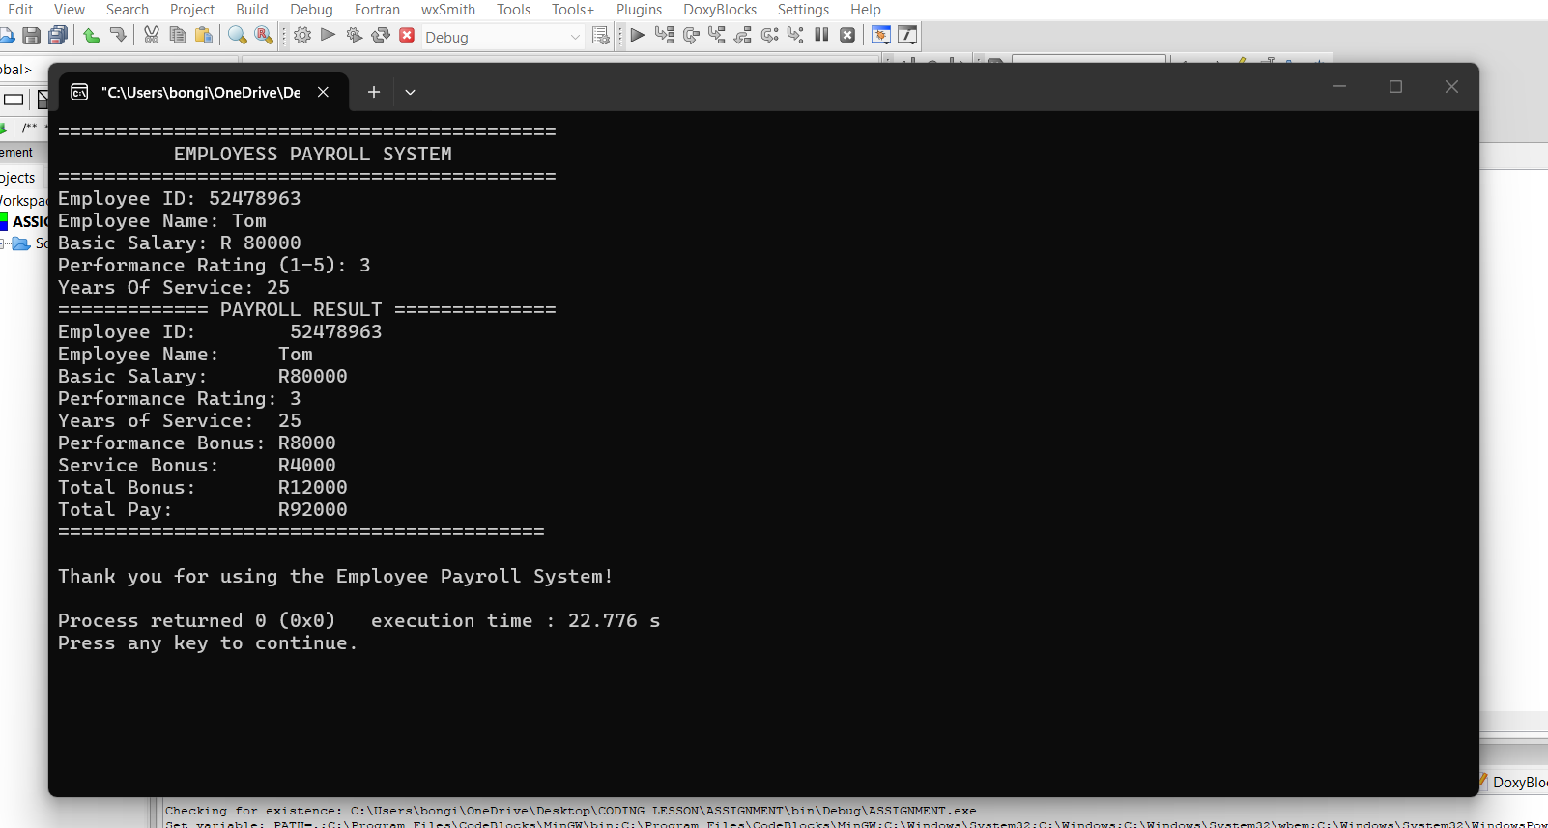

CONCLUSION:
The Employee Payroll and Bonus System illustrates the application of C++ control structures in addressing real-world problems. The program employs if and else if statements for decision-making, utilizes a for loop to handle multiple employees, and incorporates variables for storing information. Additionally, it calculates the total pay for employees. The project also offers valuable hands-on experience in input validation, program testing, documentation, and the use of GitHub.

GITHUB REPOSITORY:
GitHub Repository:
https://github.com/bmasuku519-ai/Intro-Programming-Assignment-

LINKEDIN PROFILE:
LinkedIn Profile:
www.linkedin.com/in/bongiwe-masuku-a1b971442

References:
1. Gauteng City College. Introduction to Programming — Practical Assignment 1: C++ Control Structures & Program Design. 2026.
2. C++ programming resources consulted for understanding loops, conditional statements, and data types.
3. ChatGPT. Used for programming guidance, explanations, and assistance with understanding the assignment requirements

